HOGG SUMMER THEATRE CAMPS-6 June – 3 July 2023

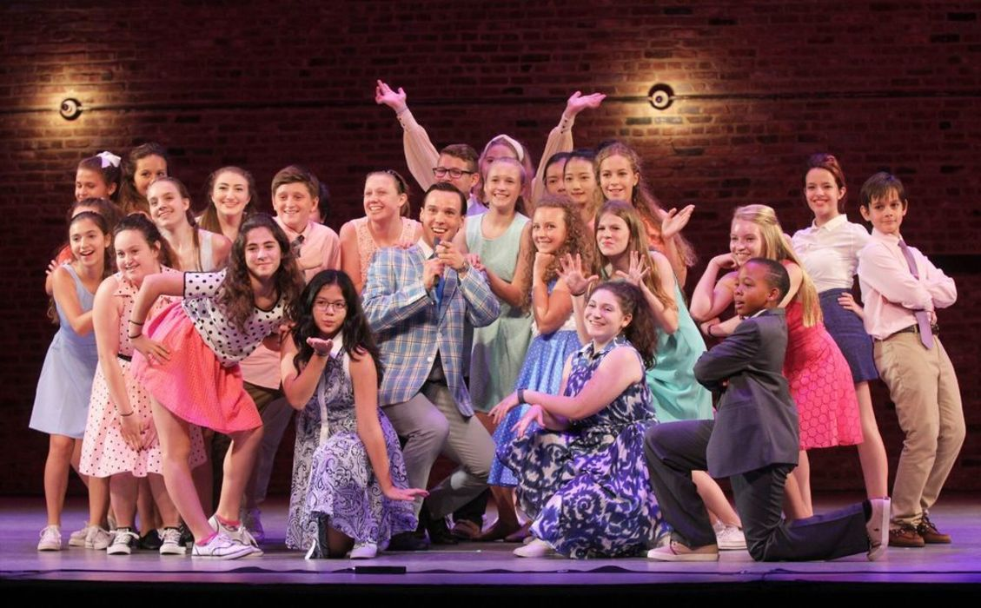

HOGG THEATRE will offer two camps on 6th June 2023.
Tuition: $0 for each participant. All students are sponsored!
Participants: Incoming 6th - 8th; Participants may attend both camps.
Clothing: Comfortable, school appropriate, able to handle movement; closed shoes
Musical Theatre: Students may bring a particular selection to share with group.
Must Bring: Closed bottle of water, Lunch for 11:00 am break if staying for 2nd session, no carbonated drinks or hot chip type snacks.

Morning Session: THEATRE CAMP from 8:30 am - 11:00 PM
FOCUS: The Story-making machine. Elements Storytelling, formal elements of fiction, voice, point of view, characterization, imagery plot and theme. Students will create limited short play scenes including blocking and self-directing. Advanced dramatic movement as well as descriptive writing and specific theater games in improvisation will be used.

Afternoon Session: MUSICAL THEATRE CAMP from 11:30am - 2:00 pm
FOCUS: Developing storytelling through acting and vocal portrayal of characters in Musical Theatre pieces, creating duet and ensemble work using imagery, plot and theme. Students will utilize skills in improvisation, scene building and dramatic movement as well as specifically designed theater games. A musical showcase with scenes will presented at the conclusion of the workshop.

